**iSWAP – EMIS version of AHP Fitness for Work Report**

**Importing the document**

Unzip the iSWAP / AHP FFWfile

In EMIS, Access Template Manager

Configuration -> Template Manager

Next select ‘Document templates’ tab as shown below

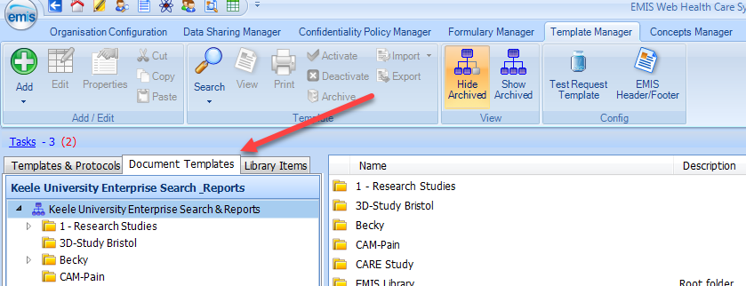

Select an existing folder from the tree or create a new folder using the ‘Add’ icon in the top left.

Then select ‘Import’ from the icons on the ribbon (see below) then ‘Document’

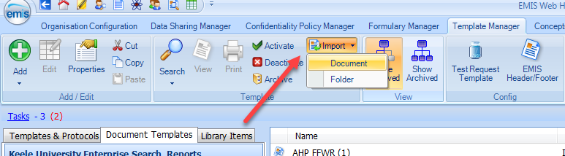

The ‘Open file’ window then opens find the document file you were sent and unzipped at step 1, select and click Open.

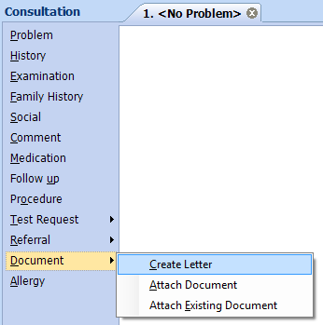The form will then be imported into the EMIS document folder.

**Accessing / Using the form**

When recording a consultation, the form can be called up by selecting Document from list of headings on the left then selecting Create letter.

Or when in a patients Care Record, 1 - selecting the Documents tab then 2 - selecting Add, Create Letter

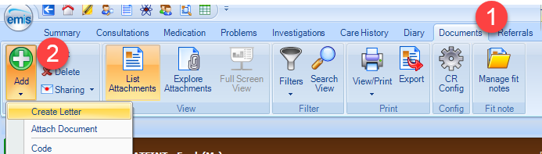

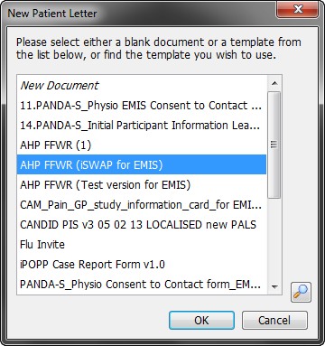

Then in the New Patient Letter window select the form from the list. And click OK.

If the form is not on the list use the magnifying glass icon in the bottom right corner to search and find the form on the system.

Once you have found it, the next time the form should be displayed on the list.

**Completing the form**

The form will then display and the patients details will have automatically completed.

You can complete the form fields as required.

Once you have finished completing the form if select File in the top left corner you have the options to print, save and save and close.

By selecting save this saves a copy of the form in the patients care record, this will not change the master file.

**Reaccessing a completed / saved form**

To reaccess a patients form, you can find it and select via the Documents tab in the Care Record.

From here you can edit (right click on document and select edit), print etc as needed.