

Osteoarthritis



A brief guide for patients with joint pain

In this guide you will find:
How to seek help for your osteoarthritis
How your health care professional can support you
Who to talk to about your joint pain
Feeling positive
Further information

Osteoarthritis, otherwise known as joint pain, is a common problem that can cause pain and stiffness in many joints in the body, such as the hips, knees or hand joints. It is more common in people aged 45 years or over, but younger people can also suffer from it. The exact cause of osteoarthritis is unknown, but genetic factors, other medical problems, the type of jobs or sports people do, previous injury and being overweight can all make people more vulnerable to having osteoarthritis.
Medical understanding of osteoarthritis is changing. Now we know that osteoarthritis is a complex problem and affects all of the joint, not just the cartilage (the material that covers the end of joints, helping them to move over one another). It is actually a process where the joint is trying to heal or repair itself - it is changing.
In some instances bone can overgrow and so the joint does not always go back to its previous state, for example, you might notice bony swellings as a result of osteoarthritis. Osteoarthritis is the result of changes to the joint.
It’s important to remember that symptoms of osteoarthritis can vary over time, between joints and
between people. Although osteoarthritis is a long term health condition it does not mean you will get progressively worse. Only a small number of people with osteoarthritis will ever require surgery. However, for the right patient, this can be an effective treatment.

Osteoarthritis
won't necessarily
get worse

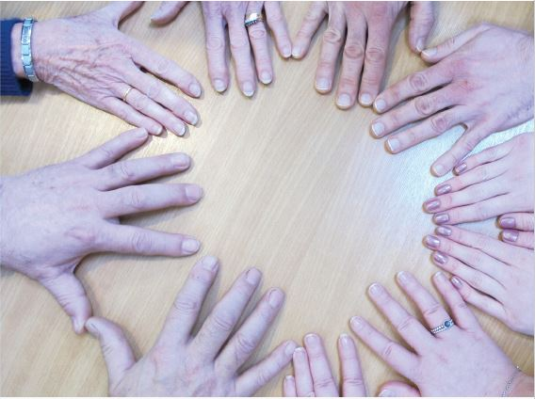

Osteoarthritis is the result of the joint trying to heal itself, resulting in changes

The good news is there are things you can do to manage your symptoms

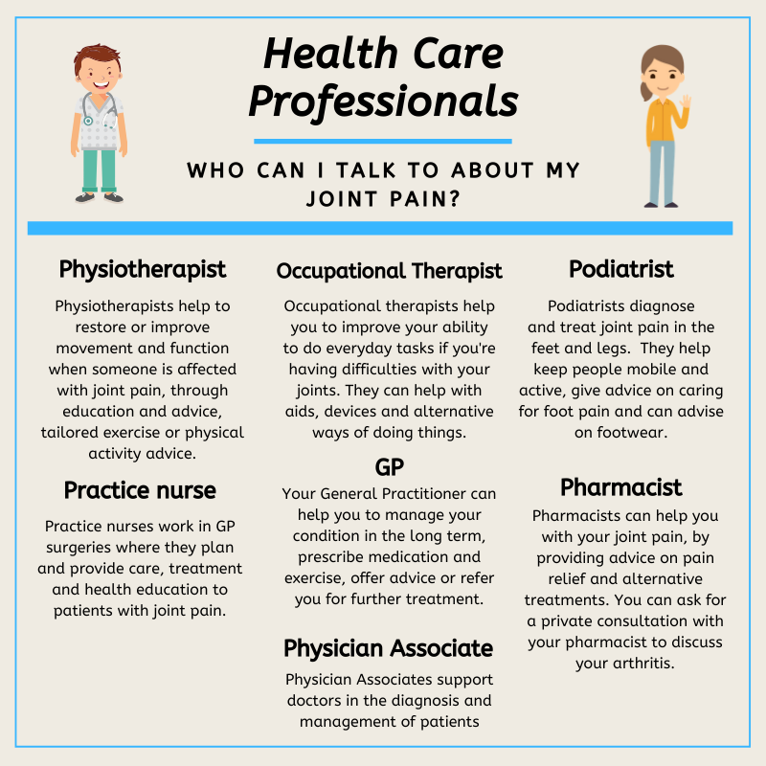

How healthcare professionals can support you to manage your osteoarthritis by:
- Providing you with written information and advice on how to move your joints regularly to keep them healthy
- Supporting you to lose weight and keep active
- Advising on appropriate pain control, such as rub-on creams containing non-steroidal anti-inflammatories, use of heat and cold
- Giving information on aids to help you and adaptations you can make
Seeking help for osteoarthritis
- The good news is, there are things you can do to improve your symptoms
- Healthcare professionals can offer extra support to help you to manage your condition
- X-rays are not usually needed for diagnosis
Feeling positive
Feeling down and frustrated is a natural and understandable reaction to experiencing pain and stiffness which can make it hard to get out and about, socialise and do your usual activities.
Both general physical activity, for example walking, swimming, cycling and specific muscle strengthening exercises for joints are an essential part of managing your osteoarthritis and can also help with your general feeling of wellbeing.
Continuing with social activities and hobbies is important for staying positive, which in turn makes it easier to cope with symptoms of osteoarthritis.

You can help your joints by keeping active

Further help
Keele University have developed a comprehensive guide to living with osteoarthritis. To access it, click here: www.jigsaw-e.com/patient-focus/guidebook/

Or, hold your phone
camera over this code:

You may find the
Keele Pain Recorder
app useful, to help you
to monitor your pain and start to understand what makes it better: www.keele.ac.uk/kpr/

For further advice and support about arthritis, visit the Versus Arthritis website: www.versusarthritis.org/ or call the helpline on 0800 5200 520




© Keele University 2019
All rights reserved. No part of this publication may be reproduced, stored in a retrieval system, or transmitted in any form by any means, electronic, mechanical, photocopying, recorded, or otherwise, without the prior written permission of Keele UniversityThis guidebook is based on research funded by the NIHR Programme Grants for Applied Research programme (RP-PG-0407-10386). The views expressed are those of the authors and not necessarily those of the NIHR or the Department of Health and Social Care.

